
NARROGIN SENIOR HIGH SCHOOL
Department of Crime Investigation

Case Number: ………………………………………………………… Date of report submission: ……………………………………
Investigating Detective: ……………………………………………………………………………………………………………………………….
Investigating Office: ……………………………………………………………………………………………………………………………………..
Chief Forensic Officer in Charge: ………………………………………………………………………………………………………………….

Discovery of the Deceased
Date of Discovery: …………………………………………………………………………………………………………………………………………
Discovers: ……………………………………………………………………………………………………………………………………………………..
Weather Conditions: …………………………………………………………………………………………………………………………………….
Summarise how the body was found by the discoverers, and what it was they thought they had found.
…………………………………………………………………………………………………………………………………………………………..…………………………………………………………………………………………………………………………………………………………………………………………………………………………………………………………………………………………………………………………………………………………………………………………………………………………………………………………………………………………………………………………………
How did the discoverers think the person had died?
………………………………………………………………………………………………………………………………………………………………………………………………………………………………………………………………………………………………………………………………………………………………………………………………………………………………………………………………………………………………………………………
Describe what happened when hikers and official police arrived at the scene, the consequences of their actions, the consequences of their use of the jackhammer, and what other items they discovered with the body.
………………………………………………………………………………………………………………………………………………………………………………………………………………………………………………………………………………………………………………………………………………………………………………………………………………………………………………………………………………………………………………………………………………………………………………………………………………………………………………………………………………………………………………………………………………………………………………………………………………………………………………………………………………………………………………………………………………………………………………………………………………………………………………………………………………………………………………………………………………………………………………………………………………………………………………………………………………………………………………………………………………………………………………………………………………………………………………………………………………………………………………………………………………………………………………………………………………………………………………………………………………………………………………………………………………
………………………………………………………………………………………………………………………………………………………………………………………………………………………………………………………………………………………………………………………………………………………………………………………………………………………………………………………………………………………………………………………
What environmental factors caused the body to be exposed and consequently found?
………………………………………………………………………………………………………………………………………………………………………………………………………………………………………………………………………………………………………………………………………………………………………………………………………………………………………………………………………………………………………………………………………………………………………………………………………………………………………………………………………………………………
What happened to the body when it was placed in the morgue?
………………………………………………………………………………………………………………………………………………………………………………………………………………………………………………………………………………………………………………………………………………………………………………………………………………………………………………………………………………………………………………………………………………………………………………………………………………………………………………………………………………………………
How did Dr Spindler treat the body? What conclusions did he draw after examining the axe found with the body?
………………………………………………………………………………………………………………………………………………………………………………………………………………………………………………………………………………………………………………………………………………………………………………………………………………………………………………………………………………………………………………………………………………………………………………………………………………………………………………………………………………………………………………………………………………………………………………………………………………………………………………………………………………………………………………………………………………………………………………………………………………………………………………………………………………………………………………………………………………………………………………………………………………………
Make notes on any other factors of the discovery that you think are important or interesting.
………………………………………………………………………………………………………………………………………………………………………………………………………………………………………………………………………………………………………………………………………………………………………………………………………………………………………………………………………………………………………………………………………………………………………………………………………………………………………………………………………………………………………………………………………………………………………………………………………………………………………………………………………………………………………………………………………………………………………………………………………………………………………………………………………………………………………………………………………………………………………………………………………………………………………………………………………………………………………………………………………………………………………………………………

Complete the following steps:
- Draw the map border of “Western Europe” on the “World Map”.
- Draw in the map border of “Location of Ötzi” on the “Western Europe map.
- On the “Location of Ötzi” map, label Austria, Italy, Switzerland, Germany and France.
- Colour each of the countries labelled in step 3 a different colour.
- Place a dot on the discovered location of Ötzi’s body.
- Ötzi was located on the borders of the following 3 countries.

- ………………………………………………..
- ………………………………………………..
- ………………………………………………..

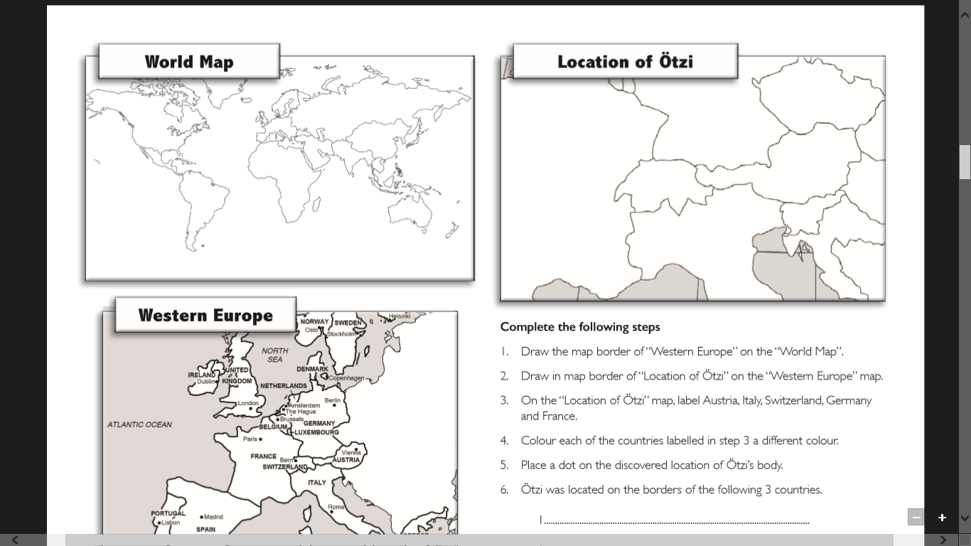

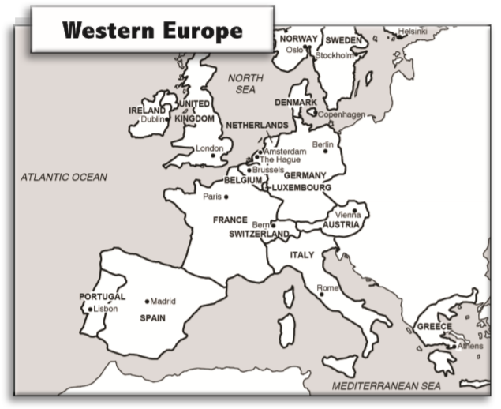

Personal Profile
Personal Details
Gender …………………………………………………
Age at time of Death ………………………………………………………. Date of Death …………………………………………
Height …………………………………………………………………………… Hair Colour …………………………………………….
Physical Condition…………………………………………………………………………………………………………………………………………
Deceased is also known as 1. ………………………………………… 2. ……………………………………………………………
Marking on the body ………………………………………………………………………………………………………………………………………………………………………………………………………………………………………………………………………………………………………………………………………………………………………………………………………………………………………………………………………………………………………………………
Where is it likely that the deceased person lived?
………………………………………………………………………………………………………………………………………………………………………………………………………………………………………………………………………………………………………………………………………………
What scientific evidence supports the theory of where the deceased person lived?
………………………………………………………………………………………………………………………………………………………………………………………………………………………………………………………………………………………………………………………………………………
Diet Details
How was the diet of the deceased determined?
………………………………………………………………………………………………………………………………………………………………………………………………………………………………………………………………………………………………………………………………………………
Modern Diet | Ötzi’s Diet
Personal Profile
Possible Occupation/Role | Pros | Cons
1.
2.
3.
4.
5.
Clothing
Name of item and image | Materials item was made from | Item’s use
1.
2.
3.
4.
5.
6.
7.
Equipment
Name of item and image | Materials item was made from | Item’s use
1.
2.
3.
4.
5.
6.
Equipment
Name of item and image | Materials item was made from | Item’s use
7.
8.
9.
10.
11.
12.
Proposed Causes of Death
Outline each theory and how the evidence and/or science supports the theory.

Theory 1 (tick a box)

………………………………………………………………………………………………………………………………………………………………………………………………………………………………………………………………………………………………………………………………………………………………………………………………………………………………………………………………………………………………………………………………………………………………………………………………………………………………………………………………………………………………………………………………………………………………………………………………………………………………………………………………………………………………………………………………………………………………………………………………………………………………………………………………………………………………………………………………………………………………………………………………………………………………………………………………………………………………………………………………………………………………………………………………………………………………………………………………………………………………………………………………………………………………………………………………………………………………………………………………………………………………………………………………………………………………………………………………………………………………………………………………………………………………………………………………………………………………………………………………………………………………………………………………………………………………………………………………………………………………………………………………
Theory 2 (tick a box)

………………………………………………………………………………………………………………………………………………………………………………………………………………………………………………………………………………………………………………………………………………………………………………………………………………………………………………………………………………………………………………………………………………………………………………………………………………………………………………………………………………………………………………………………………………………………………………………………………………………………………………………………………………………………………………………………………………………………………………………………………………………………………………………………………………………………………………………………………………………………………………………………………………………………………………………………………………………………………………………………………………………………………………………………………………………………………………………………………………………………………………………………………………………………………………………………………………………………………………………………………………………………………………………………………………………………………………………………………………………………………………………………………………………………………………………………………………………………………………………………………………………………………………………………………………………………………………………………………………………………………………………………………………………………………………………………………………………………………………………………………………………………………………………………………………………………………………………………………………………………………………………………………………………………
Theory 3 (tick a box)

………………………………………………………………………………………………………………………………………………………………………………………………………………………………………………………………………………………………………………………………………………………………………………………………………………………………………………………………………………………………………………………………………………………………………………………………………………………………………………………………………………………………………………………………………………………………………………………………………………………………………………………………………………………………………………………………………………………………………………………………………………………………………………………………………………………………………………………………………………………………………………………………………………………………………………………………………………………………………………………………………………………………………………………………………………………………………………………………………………………………………………………………………………………………………………………………………………………………………………………………………………………………………………………………………………………………………………………………………………………………………………………………………………………………………………………………………………………………………………………………………………………………………………………………………………………………………………………………………………………………………………………………………………………………………………………………………………………………………………………………………………………………………………………………………………………………………………………………………………………………………………………………………………………………

